**Agile** **Project Assignment**

**Group Based Project**

This file is presented as Project Assignment of Agile Methods in Software Development

course Instructed by **Dr**.**SALIM JIBRIN DANBATTA.**

**Team Members:**

|  |  |  |
| --- | --- | --- |
| **1.** | **MOHAMMAD RAWASS** | **210209959** |
| **2.** | **YOUCEF TCHANTCHANE** | **210209348** |
| **3.** | **MOHAMMAD ELHACHEMI MESLI** | **210209351** |
| **4.** | **BASEL ALNAJJAR** | **210209933** |
| **5.** | **HABEEB ALMSEIDEEN** | **210209439** |
| **6.** | **OSAYED ZEIN** | **210209906** |
| **7.** | **BABAH VALL** | **210209362** |
| **8.** | **HAMMAD FUAD** | **210209418** |
| **9.** | **ABDULLAH OMAR AHMED** | **210209384** |
| **10.** | **MUJTABA ODAY** | **210209928** |

**Course : Agile Methods in Software Development.**

**Course Code : (SE 404).**

**Instructor : Dr**. **SALIM JIBRIN DANBATTA.**

**Undergraduates of BSc. Software Engineering (Uskudar University, TR)**

Table of Contents:

PART 1

SECTION 1: 5

SECTION 2: 7

SECTION 3: 8

SECTION 4: 9

SECTION 5: 9

PART 2

PRODUCT BACKLOG: 12

SPRINT 1: 13

SPRINT 2: 18

SPRINT 3: 24

SPRINT 4: 29

SPRINT 5: 32

**PART 1**

# SECTION 1:

**Q) Since Naledi is unfamiliar with project management, she has requested you to choose one of the four methods she has researched: Waterfall, XP, SCRUM, and Evolutionary prototyping. Analyze and justify the project management approach you would advise Naledi to use for this project:**

**1.1 What is Scrum:**  
Scrum is an adaptable agile framework that is used in project management, primarily in software development, to improve collaboration, productivity, and flexibility. It enables teams to be flexible, adapt to changing requirements, and deliver high-quality products faster, making it popular in dynamic project environments.

**Scrum contains 3 roles:**

**-** **Product Owner**: Represents the stakeholders and is responsible for defining and prioritizing the product backlog (list of tasks/features).

**-** **Scrum Master**: Ensures the Scrum process is followed, removes obstacles and creates a positive environment, and supports the team.

**-** **Development Team**: Cross-functional team members who work together to deliver the product increments.

**There are some important terminologies we should know in Scrum method:**

**- Product Backlog:** List of functionalities with short description that are displayed in terms of user stories.

**- Sprint Backlog:** The start point of each sprint. It is a list that includes tasks selected from the Product Backlog to do in the current sprint.

**- Sprint**: A time-boxed period (usually 1-4 weeks) where the team works on tasks from the sprint backlog to produce a working project.

**- Daily Stand-Up**: A short 2 phase meeting (usually 15 minutes) where team members discuss what has been done and what is to be done.

**- Sprint Review**: Held at the end of the sprint to demonstrate what has been accomplished to the product owner and customers.

**- Sprint Retrospective**: A session to reflect on what went well and what can be improved for the next sprint.

**- Burndown Chart:** Chart that is updated every workday that tracks the progress and shows the remaining work.

**- Increment**: The final product delivered at the end of each sprint.

**Scrum Life Cycle:**

1- List the functionalities in the Product Backlog.

2- Assign the tasks to the Sprint Backlog from the Product Backlog.

3- Go to a sprint and implement the increment.

4- Release the increment.

5- Do the Sprint Review.

6- Do the Sprint Retrospective.

**1.2 Scrum vs Extreme Programming (XP):**

Scrum and XP are both agile methodologies, but they differ in their focus and approach to software development:

|  |  |  |
| --- | --- | --- |
|  | Scrum | XP |
| Focus | Project management and team roles | Engineering practices like programming and Testing |
| Iteration | 2-4 weeks (Sprint) | 1-2 weeks |
| Handling Changes | No changes during the Sprint | Flexible changes during the iteration |

**1.3 Why we chose Scrum:**

Scrum is suitable for projects where requirements may change, as Naledi is unfamiliar with the developing process and has no specific requirements planed, and the most important that “Shaka Jobs” (The app name) as the first hint gives that it is a platform in the dynamic job market (recruitments) which it should be flexible to changes in job search trends, technology, and user feedback as the job market updated frequently.

Choosing Scrum can lead to better team morale, more productive workflows, and higher satisfaction from stakeholders due to its structured yet adaptable nature. It’s ideal for this type of project.

# SECTION 2:

**Q) Explain why you think she should follow your advice, and list any dangers or drawbacks she should be aware of:**

**2.1 Why Naledi should follow our advice:**

**- Adaptability**: With its iterative nature, one of Scrum's core strengths is the ability to adapt to changing requirements. As for Naledi’s requested App where dynamics of the job market, user expectations, and search trends are updatable, adaptability of Scrum becomes a significant advantage.

**- Better collaboration with stakeholders:** Scrum promotes a consistent communication with stakeholders by doing meetings regularly, which is essential for a platform like “Shaka Jobs” that covers different user needs.

**- Fast delivery of high quality:** Scrum achieves fast delivery of high-quality products by focusing on small and manageable sprints that allow the team to complete and test features incrementally. After each sprint (Exactly in the sprint review), the stakeholder gives feedback to ensure alignment with user expectations and allows quick adjustments. This feature makes sure that the product delivers value sooner and adapts to changing needs, enhancing productivity and quality over time.

**- Reduced Risk:** Scrum reduces risk by breaking down the project into sprints. Each sprint acts as a mini project, allowing the team to identify and address risks within a controlled timeframe. Also, the structure of reviews and retrospectives after each sprint (Sprint Review & Retrospective) further helps in spotting potential risks early and adjusting plans accordingly.

**2.2 Drawbacks and dangers of Scrum we should be aware of:**

**- Requires Agile Mindset:** Scrum only works well if the team fully embraces agile principles. Without an agile mindset, teams might struggle with Scrum’s need for flexibility, collaboration, and quick adaptation, leading to confusion and missed goals. Teams that are used to traditional methods may find it hard to adjust to Scrum’s fast-paced and iterative approach, reducing its effectiveness.

**- Team Commitment:** Scrum requires everyone to be proactive and communicative, with regular check-ins and accountability for each task. If one member isn’t fully engaged, it can disrupt our sprint cycles and timelines, so this will demand consistent involvement from everyone.

**- Lack of Management Trust**: Scrum depends on managers trusting the development team to handle their work independently during each sprint. Without this trust, managers might start to micromanage, which takes away the team’s freedom to work effectively. This can hurt teamwork, limit creative solutions, and stop the team from getting the full benefits of Scrum.

**- Burnout Risk**: The fast-paced nature of frequent sprints with high accountability can lead to team burnout if not managed properly, especially when teams are consistently under pressure to deliver increments.

# SECTION 3:

**Q) Naledi must also describe to her team, stakeholders, and herself the nature of projects and how it varies from conducting business as usual:**

**3.1 Scrum vs. Business As Usual (BAU):**  
When Naledi explains Scrum to her team, stakeholders, and even herself, she’s talking about a flexible, collaborative way of working that’s a big change from the usual “Business As Usual” (BAU) style. Scrum, part of Agile project management, is all about teamwork, fast adjustments, and constant feedback. Instead of aiming for one final, polished product at the end of a long timeline, Scrum runs on short, focused cycles called “sprints,” usually two to four weeks each. Every sprint helps the team make steady progress, letting them respond quickly to new information and adapt to feedback as they go.

**Key Scrum Practices:**

**- Sprint Planning:** The team sets priorities and realistic goals at the start of each sprint.

**- Daily Stand-ups:** Short, daily check-ins to share progress and tackle any issues, keeping everyone in sync.

**- Sprint Review:** At the end of each sprint, the team shows their work to stakeholders to gather feedback.

- **Sprint Retrospective:** A look-back session to see what worked well and what could improve, aiming for constant progress.

**How Scrum Differs from BAU:**

**- Focus:** BAU is all about stability. Scrum is adaptable, aiming to create value and respond to changes fast.

**- Structure:** BAU sticks to set processes. Scrum works in flexible sprints.

**- Roles:** BAU has fixed roles. Scrum encourages shared responsibilities.

**- Handling Change:** BAU avoids change. Scrum embraces it.

# SECTION 4:

**Q) Naledi must defend the hiring of a project manager in her report. Give an overview of the advantages of having one, the vital expertise they could contribute to the project, and how they might need to modify their management style to meet the suggested project management methodology:**

**4.1 Defending having a project manager:**

Having a project manager is helpful for the success of any project. Here’s why every project needs one:

**- Ordering:** A project manager brings order to what can easily become chaos. They make sure everyone knows what their tasks are, deadlines are met, and resources are used wisely. Without this coordination, projects can

fall apart, with people unsure of what to do and wasting time and materials. A project manager keeps everything on track, ensuring that the project moves forward smoothly.

**- Risk Predicter:** Project managers are great at spotting problems before they happen. They look ahead, identify risks, and make plans to prevent or fix any issues. Without someone keeping an eye on potential dangers, a project can quickly go off course. A project manager helps avoid costly mistakes and delays, making sure things stay on target.

**- Ensure Communication:** Communication is key to any project, and this is where project managers excel. They make sure everyone involved – from team members to clients – is updated and on the same page. Miscommunication can lead to mistakes, missed deadlines, and confusion. A project manager ensures that everyone is informed, working together, and moving toward the same goal.

In short, having a project manager means better organization, fewer risks, and clear communication, all of which lead to a more successful project. If you want your project to run smoothly and succeed, you need a project manager.

# SECTION 5:

**Q) In the event that Naledi appoints you as a project manager, please describe how the dangers mentioned in question 2 will affect the triangle of time, quality, and cost. Which one would you choose to give in on if you had to choose? Justify your response, please:**

**5.1 Impact on Time, Quality, Cost :**

If Naledi makes me the project manager, here’s how I think the risks from Scrum could affect the project's time, quality, and cost balance, known as the project management triangle:

**- Time**: Since Scrum relies on regular sprints and requires an agile mindset, any delay (like a team member not fully committing)can throw off our timeline. If everyone isn’t fully engaged or if management steps in too much, it could disrupt our sprints and push back delivery dates. This would mean extending timelines, which could also increase costs and stress the team.

**- Quality:** The intense pace of Scrum could lead to burnout, especially if we’re under constant pressure to deliver sprint after sprint. Burnout or fatigue could impact on the quality of work since people may cut corners just to meet deadlines. If the team doesn’t get enough time to recharge, the quality of the final product could suffer, which might mean going back to fix issues later on(again increasing time and cost).

**- Cost:** If the burnout sets in and quality drops, we might have to spend extra time fixing things, which increase costs. Plus, if managers don’t trust the team to work independently (Lack of management), they might end up overseeing tasks too closely, which can slow things down and potentially increase project management costs.

**5.2 Choosing one to give on:**

If I had to choose one area to give in on, I’d probably choose Time.

Quality is key to delivering a solid product, and managing costs is important to keep the project viable. If we allow for a bit more time, the team can work at a sustainable pace without risking burnout, which ultimately helps with both quality and cost management. Adding some time for each sprint could keep the team fresh, maintain high-quality output, and avoid unexpected expenses in the long run.

***\*\*\****

**PART 2**

# PRODUCT BACKLOG:

Table 1: Product Backlog

|  |  |  |  |  |  |  |  |
| --- | --- | --- | --- | --- | --- | --- | --- |
| ID | Role | Feature | User Story | Points | Status | Priority | Sprint |
| 1 | All Users | User Authentication | As a user, I want to register and log in so I can access the app securely. | 8 | Pending | High | Sprint 1 |
| 2 | All Users | Role-Based Dashboard | As a user, I want to see a dashboard tailored to my role (employee or manager) so I can access relevant information easily. | 7 | Pending | High | Sprint 1 |
| 3 | All Users | Profile Management | As a user, I want to edit my profile so I can keep my information up to date. And as a manager I want to change and update my company profile | 8 | Pending | High | Sprint 1 |
| 4 | Manager | Event Creation | As a manager, I want to create events with details like name, description, date, time, and location so I can engage my team. | 9 | Pending | High | Sprint 2 |
| 5 | Manager | Event Invitations | As a manager, I want to invite employees to events so they can participate. | 4 | Pending | High | Sprint 2 |
| 6 | Employee | ( yes, no, interested) System | As an employee, I want to (yes, no, interested) to events so I can confirm or decline my attendance. | 2 | Pending | High | Sprint 2 |
| 7 | Manager | Group Admin Assignment | As a manager, I want to assign a group admin for each event so they can help manage event details and group chats. | 4 | Pending | High | Sprint 2 |
| 8 | All Users | Event Details Page | As a user, I want to view detailed information about an event so I can decide if I want to attend. | 5 | Pending | High | Sprint 2 |
| 9 | All Users | Group Chat for Events | As a user, I want a group chat for each event so I can communicate with other participants. | 8 | Pending | High | Sprint 3 |
| 10 | Group Admin | Admin Controls for Group Chat | As a group admin, I want to moderate the group chat by pinning messages, removing inappropriate messages, and posting announcements. | 7 | Pending | Medium | Sprint 3 |
| 11 | All Users | Employee Directory | As a user, I want to browse a directory of employees so I can view their profiles and invite them to events. | 8 | Pending | Medium | Sprint 3 |
| 12 | All Users | Search and Filter in Directory | As a user, I want to search and filter employees in the directory by name or department so I can find the right person. | 6 | Pending | Medium | Sprint 3 |
| 13 | All Users | Real-Time Notifications | As a user, I want to receive notifications for new event invitations, group chat updates, and event changes in real time. | 6 | Pending | High | Sprint 4 |
| 14 | All Users | Notification Settings | As a user, I want to manage my notification preferences (email, push, or in-app) so I can control how I am notified. | 3 | Pending | Medium | Sprint 4 |
| 15 | All Users | UI/UX Refinements | As a user, I want an intuitive and visually appealing interface so I can easily navigate the app. | 6 | Pending | Medium | Sprint 4 |
| 16 | All Users | Accessibility Features | As a user with accessibility needs, I want options like larger fonts and screen reader compatibility so I can use the app effectively. | 3 | Pending | Low | Sprint 4 |
| 17 | Manager | Manager Analytics Dashboard | As a manager, I want to view engagement trends, RSVP statistics, and feedback summaries so I can understand team participation and morale. | 6 | Pending | High | Sprint 5 |
| 18 | Developer | Final Testing and Integration | As a developer, I want to test and integrate all features so the app functions seamlessly for users. | 9 | Pending | High | Sprint 5 |
| 19 | Stakeholder | Prototype Presentation | As a stakeholder, I want a polished prototype showcasing all features so I can evaluate and present the app. | 3 | Pending | High | Sprint 5 |

# SPRINT 1:

Table 2: Sprint 1

|  |  |  |  |  |  |
| --- | --- | --- | --- | --- | --- |
| **Sprint 1 (1 Week)** | | | | | |
| **Goal:** Build the core features required to access and navigate the app. | | | | | |
| **Day 1** | | | | | |
| **ID** | **User Story** | **Tasks** | **Assigned To** | **Priority** | **Status** |
| US-001 | User Authentication | * Create employee and employer registration/login pages. | Habeeb | High | In Progress |
| US-002 | Role Based Dashboard | * Create Activities page for employees (Placeholder for event invitations and recent involvement). * Create dashboard for managers (Placeholder for event creation and analytics). | Habeeb | High | On Hold |
| US-003 | Profile Management | * Create an employee profile management where he can edit his profile. * Create a manager profile management where he can change and update the company profile. | Habeeb | High | On Hold |
| **Day 2** | | | | | |
| **Day 3** | | | | | |
| US-001 | User Authentication | * Create employee and employer registration/login pages. | Habeeb | High | Done |
| US-002 | Role Based Dashboard | * Create Activities page for employees (Placeholder for event invitations and recent involvement). * Create dashboard for managers (Placeholder for event creation and analytics). | Habeeb | High | In Progress |
| US-003 | Profile Management | * Create an employee profile management where he can edit his profile. * Create a manager profile management where he can change and update the company profile. | Habeeb | High | On Hold |
| **Day 4** | | | | | |
| **Day 5** | | | | | |
| US-001 | User Authentication | * Create employee and employer registration/login pages. | Habeeb | High | Done |
| US-002 | Role Based Dashboard | * Create Activities page for employees (Placeholder for event invitations and recent involvement). * Create dashboard for managers (Placeholder for event creation and analytics). | Habeeb | High | Done |
| US-003 | Profile Management | * Create an employee profile management where he can edit his profile. * Create a manager profile management where he can change and update the company profile. | Habeeb | High | In Progress |
| **Day 6** | | | | | |
| **Day 7** | | | | | |
| US-001 | User Authentication | * Create employee and employer registration/login pages. | Habeeb | High | Done |
| US-002 | Role Based Dashboard | * Create Activities page for employees (Placeholder for event invitations and recent involvement). * Create dashboard for managers (Placeholder for event creation and analytics). | Habeeb | High | Done |
| US-003 | Profile Management | * Create an employee profile management where he can edit his profile. * Create a manager profile management where he can change and update the company profile. | Habeeb | High | Done |
| **Last Day: Sprint 1 Review** | | | | | |

Figure 1: Authentication Page

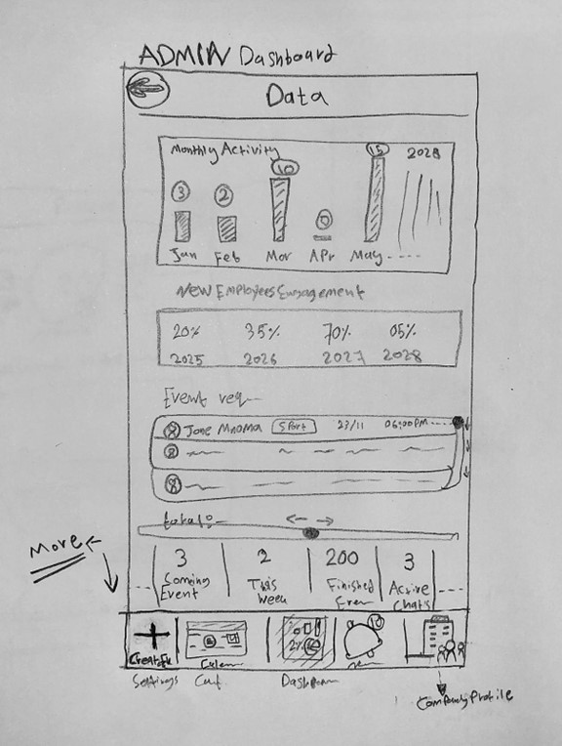

Figure 2: Main Page Figure 3: Admin Dashboard Page

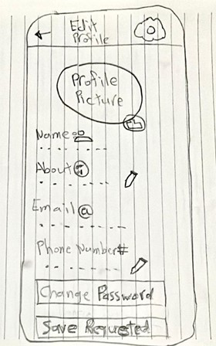

Figure 4: My Profile Page Figure 5: Edit Profile Page

# SPRINT 2:

Table 3: Sprint 2

|  |  |  |  |  |  |
| --- | --- | --- | --- | --- | --- |
| **Sprint 2 (2-3 Weeks)** | | | | | |
| **Goal:** Enable users to create, invite, and participate in events. | | | | | |
| **Day 1** | | | | | |
| **ID** | **User Story** | **Tasks** | **Assigned To** | **Priority** | **Status** |
| US-004 | Event Creation | * Create a “Create an event” page where the manager can create events with details like name, description, date, time, and location. * Let the manager post the event in the main page. | Habeeb | High | In Progress |
| US-005 | Event invitations | Create a feature where the manager can invite employees to the events. | Habeeb | High | On Hold |
| US-006 | Reply to events | Create a feature where the employee can reply with (Yes/No/Interested) to the events. | Habeeb | High | On Hold |
| US-007 | Group Admin Assignment | Create a feature where the manager can assign someone as an event admin. | Habeeb | High | On Hold |
| US-008 | Event Details Page | Create a feature where the user can view detailed information about an event. | Habeeb | High | On Hold |
| **Day 2** | | | | | |
| **Day 3** | | | | | |
| **Day 4** | | | | | |
| US-004 | Event Creation | * Create a “Create an event” page where the manager can create events with details like name, description, date, time, and location. * Let the manager post the event in the main page. | Habeeb | High | Done |
| US-005 | Event invitations | Create a feature where the manager can invite employees to the events. | Habeeb | High | In Progress |
| US-006 | Reply to events | Create a feature where the employee can reply with (Yes/No/Interested) to the events. | Habeeb | High | On Hold |
| US-007 | Group Admin Assignment | Create a feature where the manager can assign someone as an event admin. | Habeeb | High | On Hold |
| US-008 | Event Details Page | Create a feature where the user can view detailed information about an event. | Habeeb | High | On Hold |
| **Day 5** | | | | | |
| **Day 6** | | | | | |
| US-004 | Event Creation | * Create a “Create an event” page where the manager can create events with details like name, description, date, time, and location. * Let the manager post the event in the main page. | Habeeb | High | Done |
| US-005 | Event invitations | Create a feature where the manager can invite employees to the events. | Habeeb | High | Done |
| US-006 | Reply to events | Create a feature where the employee can reply with (Yes/No/Interested) to the events. | Habeeb | High | In Progress |
| US-007 | Group Admin Assignment | Create a feature where the manager can assign someone as an event admin. | Habeeb | High | On Hold |
| US-008 | Event Details Page | Create a feature where the user can view detailed information about an event. | Habeeb | High | On Hold |
| **Day 7** | | | | | |
| **Day 8** | | | | | |
| US-004 | Event Creation | * Create a “Create an event” page where the manager can create events with details like name, description, date, time, and location. * Let the manager post the event in the main page. | Habeeb | High | Done |
| US-005 | Event invitations | Create a feature where the manager can invite employees to the events. | Habeeb | High | Done |
| US-006 | Reply to events | Create a feature where the employee can reply with (Yes/No/Interested) to the events. | Habeeb | High | Done |
| US-007 | Group Admin Assignment | Create a feature where the manager can assign someone as an event admin. | Habeeb | High | In Progress |
| US-008 | Event Details Page | Create a feature where the user can view detailed information about an event. | Habeeb | High | On Hold |
| **Day 9** | | | | | |
| US-004 | Event Creation | * Create a “Create an event” page where the manager can create events with details like name, description, date, time, and location. * Let the manager post the event in the main page. | Habeeb | High | Done |
| US-005 | Event invitations | Create a feature where the manager can invite employees to the events. | Habeeb | High | Done |
| US-006 | Reply to events | Create a feature where the employee can reply with (Yes/No/Interested) to the events. | Habeeb | High | Done |
| US-007 | Group Admin Assignment | Create a feature where the manager can assign someone as an event admin. | Habeeb | High | Done |
| US-008 | Event Details Page | Create a feature where the user can view detailed information about an event. | Habeeb | High | In Progress |
| **Day 10** | | | | | |
| **Day 11** | | | | | |
| US-004 | Event Creation | * Create a “Create an event” page where the manager can create events with details like name, description, date, time, and location. * Let the manager post the event in the main page. | Habeeb | High | Done |
| US-005 | Event invitations | Create a feature where the manager can invite employees to the events. | Habeeb | High | Done |
| US-006 | Reply to events | Create a feature where the employee can reply with (Yes/No/Interested) to the events. | Habeeb | High | Done |
| US-007 | Group Admin Assignment | Create a feature where the manager can assign someone as an event admin. | Habeeb | High | Done |
| US-008 | Event Details Page | Create a feature where the user can view detailed information about an event. | Habeeb | High | Done |
| **Last Day: Sprint 2 Review** | | | | | |

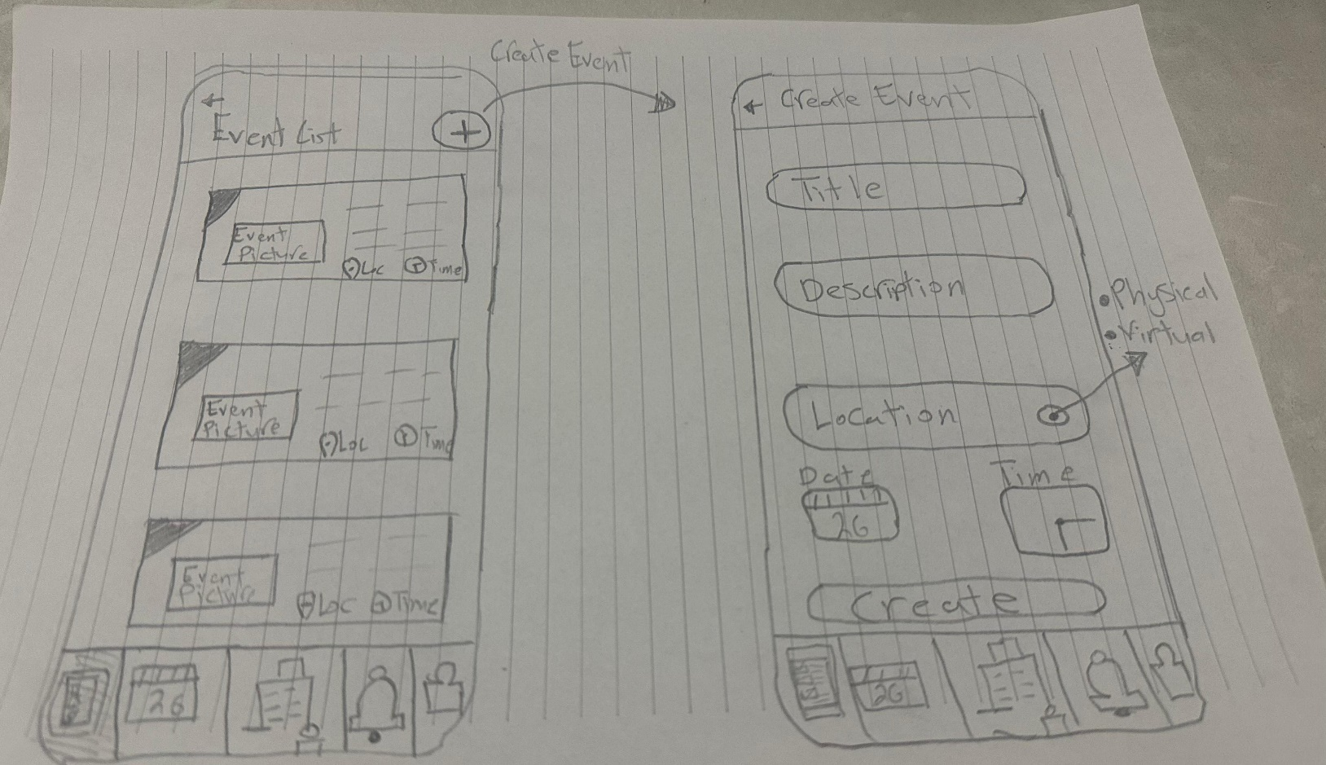

Figure 6: Create Event Page

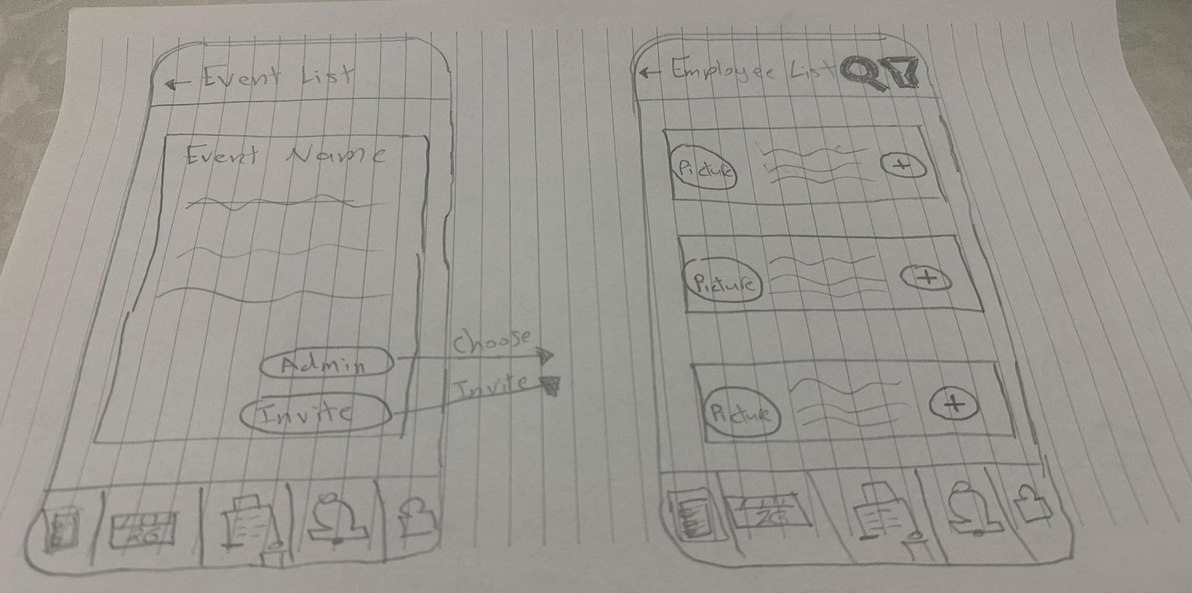

Figure 7: Add Event’s Admin Page

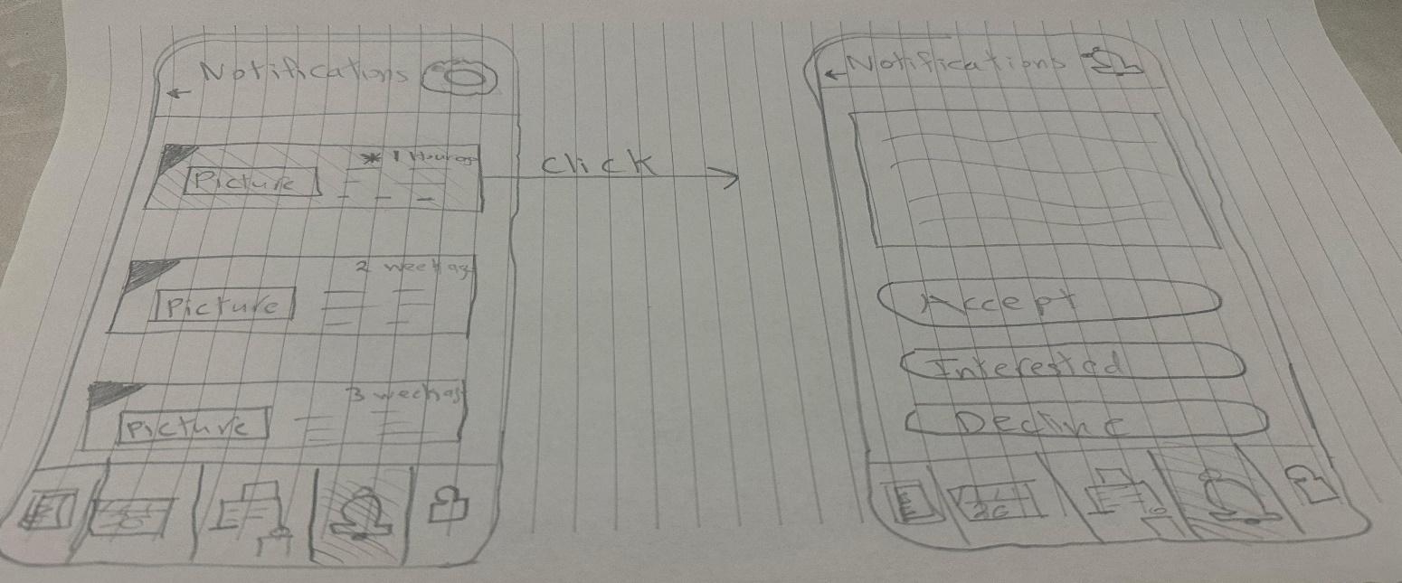

Figure 8: Invitation Acceptance Page

Figure 9: Callender Page

# SPRINT 3:

Table 4: Sprint 3

|  |  |  |  |  |  |
| --- | --- | --- | --- | --- | --- |
| **Sprint 3 (2-3 Weeks)** | | | | | |
| **Goal:** Build communication and interaction tools for employees. | | | | | |
| **Day 1** | | | | | |
| **ID** | **User Story** | **Tasks** | **Assigned To** | **Priority** | **Status** |
| US-009 | Group Chat for Events | Create a group chat for the events. | Habeeb | High | In Progress |
| US-010 | Admin Controls for Group Chat | Create a feature where the group admin can moderate the group chat by pinning messages, removing inappropriate messages, and posting announcements. | Habeeb | Medium | On Hold |
| US-011 | Employee Directory | Create a feature where the user can browse a directory of employees so he can view their profiles and invite them to events. | Habeeb | Medium | On Hold |
| US-012 | Search and Filter in Directory | Create a feature where the user can search and filter employees in the directory by name or department. | Habeeb | Medium | On Hold |
| **Day 2** | | | | | |
| **Day 3** | | | | | |
| **Day 4** | | | | | |
| US-009 | Group Chat for Events | Create a group chat for the events. | Habeeb | High | Done |
| US-010 | Admin Controls for Group Chat | Create a feature where the group admin can moderate the group chat by pinning messages, removing inappropriate messages, and posting announcements. | Habeeb | Medium | In Progress |
| US-011 | Employee Directory | Create a feature where the user can browse a directory of employees so he can view their profiles and invite them to events. | Habeeb | Medium | On Hold |
| US-012 | Search and Filter in Directory | Create a feature where the user can search and filter employees in the directory by name or department. | Habeeb | Medium | On Hold |
| **Day 5** | | | | | |
| **Day 6** | | | | | |
| **Day 7** | | | | | |
| US-009 | Group Chat for Events | Create a group chat for the events. | Habeeb | High | Done |
| US-010 | Admin Controls for Group Chat | Create a feature where the group admin can moderate the group chat by pinning messages, removing inappropriate messages, and posting announcements. | Habeeb | Medium | Done |
| US-011 | Employee Directory | Create a feature where the user can browse a directory of employees so he can view their profiles and invite them to events. | Habeeb | Medium | In Progress |
| US-012 | Search and Filter in Directory | Create a feature where the user can search and filter employees in the directory by name or department. | Habeeb | Medium | On Hold |
| **Day 8** | | | | | |
| **Day 9** | | | | | |
| **Day 10** | | | | | |
| US-009 | Group Chat for Events | Create a group chat for the events. | Habeeb | High | Done |
| US-010 | Admin Controls for Group Chat | Create a feature where the group admin can moderate the group chat by pinning messages, removing inappropriate messages, and posting announcements. | Habeeb | Medium | Done |
| US-011 | Employee Directory | Create a feature where the user can browse a directory of employees so he can view their profiles and invite them to events. | Habeeb | Medium | Done |
| US-012 | Search and Filter in Directory | Create a feature where the user can search and filter employees in the directory by name or department. | Habeeb | Medium | In Progress |
| **Day 11** | | | | | |
| **Day 12** | | | | | |
| US-009 | Group Chat for Events | Create a group chat for the events. | Habeeb | High | Done |
| US-010 | Admin Controls for Group Chat | Create a feature where the group admin can moderate the group chat by pinning messages, removing inappropriate messages, and posting announcements. | Habeeb | Medium | Done |
| US-011 | Employee Directory | Create a feature where the user can browse a directory of employees so he can view their profiles and invite them to events. | Habeeb | Medium | Done |
| US-012 | Search and Filter in Directory | Create a feature where the user can search and filter employees in the directory by name or department. | Habeeb | Medium | Done |
| **Last Day: Sprint 3 Review** | | | | | |

Figure 10: Group Chat Page

Figure 11: Employee Directory Page

# SPRINT 4:

Table 5: Sprint 4

|  |  |  |  |  |  |
| --- | --- | --- | --- | --- | --- |
| **Sprint 4 (1-2 Weeks)** | | | | | |
| **Goal:** Improve usability and real-time functionality of the app. | | | | | |
| **Day 1** | | | | | |
| **ID** | **User Story** | **Tasks** | **Assigned To** | **Priority** | **Status** |
| US-013 | Real-Time Notifications | Create a feature where the user can receive notifications for new event invitations, group chat updates, and event changes in real time. | Habeeb | High | In Progress |
| US-014 | Notification Settings | Create a feature where the user can manage his notification preferences (Email, Push, In-App). | Habeeb | Medium | On Hold |
| US-015 | UI/UX Refinements | Implement a good-looking user interface and experience. | Habeeb | Medium | On Hold |
| US-016 | Accessibility Features | Create a feature where the user can change options like larger fonts and screen reader compatibility. | Habeeb | Low | On Hold |
| **Day 2** | | | | | |
| **Day 3** | | | | | |
| US-013 | Real-Time Notifications | Create a feature where the user can receive notifications for new event invitations, group chat updates, and event changes in real time. | Habeeb | High | Done |
| US-014 | Notification Settings | Create a feature where the user can manage his notification preferences (Email, Push, In-App). | Habeeb | Medium | In Progress |
| US-015 | UI/UX Refinements | Implement a good-looking user interface and experience. | Habeeb | Medium | On Hold |
| US-016 | Accessibility Features | Create a feature where the user can change options like larger fonts and screen reader compatibility. | Habeeb | Low | On Hold |
| **Day 4** | | | | | |
| US-013 | Real-Time Notifications | Create a feature where the user can receive notifications for new event invitations, group chat updates, and event changes in real time. | Habeeb | High | Done |
| US-014 | Notification Settings | Create a feature where the user can manage his notification preferences (Email, Push, In-App). | Habeeb | Medium | Done |
| US-015 | UI/UX Refinements | Implement a good-looking user interface and experience. | Habeeb | Medium | In Progress |
| US-016 | Accessibility Features | Create a feature where the user can change options like larger fonts and screen reader compatibility. | Habeeb | Low | On Hold |
| **Day 5** | | | | | |
| **Day 6** | | | | | |
| US-013 | Real-Time Notifications | Create a feature where the user can receive notifications for new event invitations, group chat updates, and event changes in real time. | Habeeb | High | Done |
| US-014 | Notification Settings | Create a feature where the user can manage his notification preferences (Email, Push, In-App). | Habeeb | Medium | Done |
| US-015 | UI/UX Refinements | Implement a good-looking user interface and experience. | Habeeb | Medium | Done |
| US-016 | Accessibility Features | Create a feature where the user can change options like larger fonts and screen reader compatibility. | Habeeb | Low | In Progress |
| **Day 7** | | | | | |
| US-013 | Real-Time Notifications | Create a feature where the user can receive notifications for new event invitations, group chat updates, and event changes in real time. | Habeeb | High | Done |
| US-014 | Notification Settings | Create a feature where the user can manage his notification preferences (Email, Push, In-App). | Habeeb | Medium | Done |
| US-015 | UI/UX Refinements | Implement a good-looking user interface and experience. | Habeeb | Medium | Done |
| US-016 | Accessibility Features | Create a feature where the user can change options like larger fonts and screen reader compatibility. | Habeeb | Low | Done |
| **Last Day: Sprint 4 Review** | | | | | |

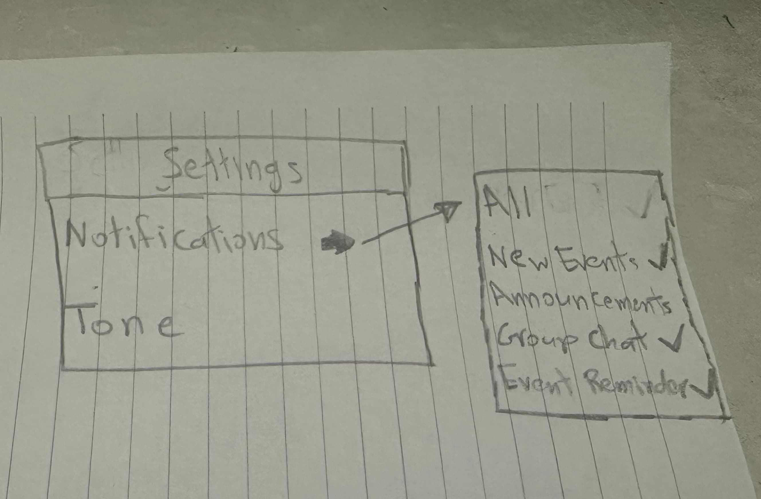

Figure 12: Notifications Settings Page

# SPRINT 5:

Table 6: Sprint 5

|  |  |  |  |  |  |
| --- | --- | --- | --- | --- | --- |
| **Sprint 5 (1-2 Weeks)** | | | | | |
| **Goal:** Add analytics for managers and finalize all features. | | | | | |
| **Day 1** | | | | | |
| **ID** | **User Story** | **Tasks** | **Assigned To** | **Priority** | **Status** |
| US-017 | Manager Analytics Dashboard | Create a feature where the manager can view the dashboard (engagement trends, event reply’s statistics, and feedback summaries). | Habeeb | High | In Progress |
| US-018 | Final Testing and Integration | Test and integrate all features in the app. | Habeeb | High | On Hold |
| US-019 | Prototype Presentation | Deliver a prototype and present the app. | Habeeb | High | On Hold |
| **Day 2** | | | | | |
| **Day 3** | | | | | |
| US-017 | Manager Analytics Dashboard | Create a feature where the manager can view the dashboard (engagement trends, event reply’s statistics, and feedback summaries). | Habeeb | High | Done |
| US-018 | Final Testing and Integration | Test and integrate all features in the app. | Habeeb | High | In Progress |
| US-019 | Prototype Presentation | Deliver a prototype and present the app. | Habeeb | High | On Hold |
| **Day 4** | | | | | |
| **Day 5** | | | | | |
| **Day 6** | | | | | |
| US-017 | Manager Analytics Dashboard | Create a feature where the manager can view the dashboard (engagement trends, event reply’s statistics, and feedback summaries). | Habeeb | High | Done |
| US-018 | Final Testing and Integration | Test and integrate all features in the app. | Habeeb | High | Done |
| US-019 | Prototype Presentation | Deliver a prototype and present the app. | Habeeb | High | In Progress |
| **Day 7** | | | | | |
| US-017 | Manager Analytics Dashboard | Create a feature where the manager can view the dashboard (engagement trends, event reply’s statistics, and feedback summaries). | Habeeb | High | Done |
| US-018 | Final Testing and Integration | Test and integrate all features in the app. | Habeeb | High | Done |
| US-019 | Prototype Presentation | Deliver a prototype and present the app. | Habeeb | High | Done |
| **Last Day: Sprint 5 Review** | | | | | |

***THE END***